St. Francis Institute of Technology, Mumbai-400 103

**Department of Information Technology**

A.Y. 2023-2024

Class: TE-ITA/B, Semester: V

Subject: **Advanced DevOps Lab**

**Experiment – 3: A lambda function using cloud9 IDE and collaborate with other users over cloud9 IDE.**

**1. Aim:** To create, deploy and invoke a lambda function using cloud9 IDE and collaborate with other users over cloud9 IDE.

**2. Objectives:** After study of this experiment, the student will be able to

**●** Create lambda function and use s3 bucket to deploy code and invoke lambda function through terminal.

**●** Use existing lambda function and make changes, upload and invoke it.

**●** Debug lambda function in the IDE

● Collaborate with other users.

**3. Lab objective mapped : ITL504.1:** To understand the fundamentals of Cloud Computing and be fully proficient with Cloud based DevOps solution deployment options to meet your business requirements.

**4. Prerequisite:** Fundamentals of IDE

**5. Requirements:** Computer, Windows operating system, Internet Connection, web browser, AWS cloud account.

**6. Pre-Experiment Exercise:**

**Brief Theory:**(write in hand)

Cloud9 IDE

AWS Lambda

IAM

**7. Laboratory Exercise**

Create, deploy and invoke a lambda function

1. AWS lambda console, check if no function present in your account.

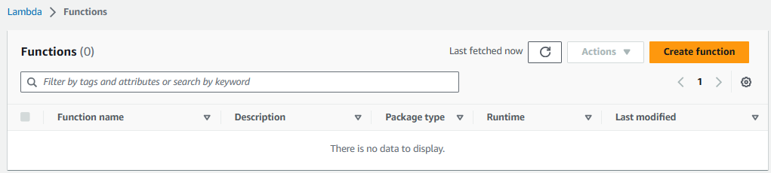

2. Go to aws explorer of cloud9 IDE

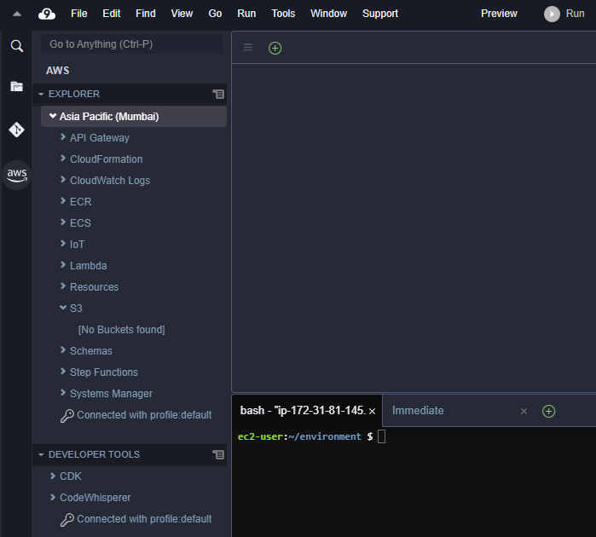

3. create lambda SAM application

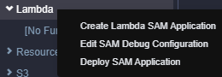

4. select python 3.7 version

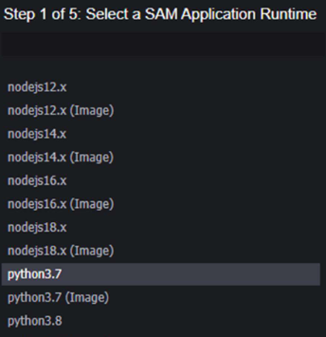

5. select SAM hello world basic app

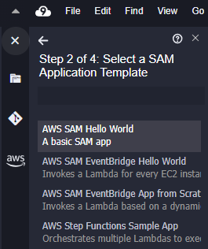

6. select work env folder

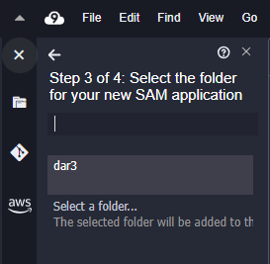

7. give name to your application

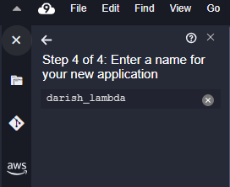

8. from folder open to app.py lambda python file

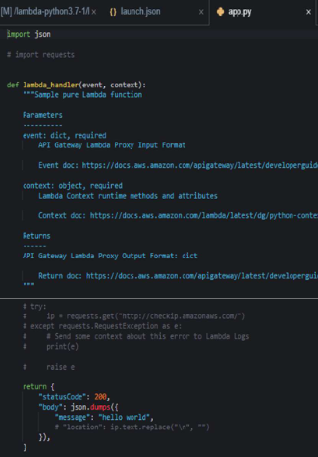

9. make changes to this file

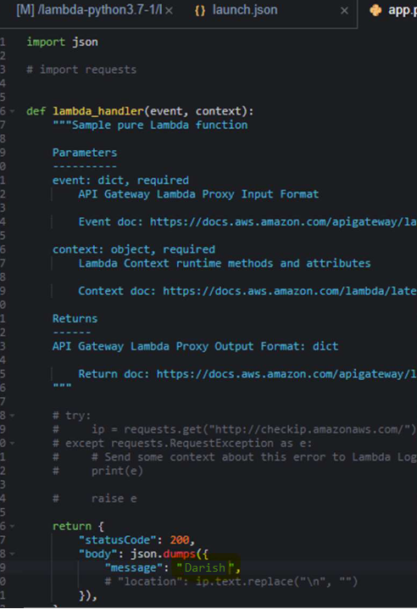

10. save and deploy

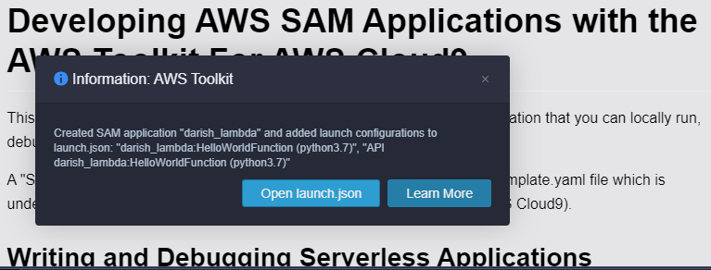

11. select s3 bucket to deploy code

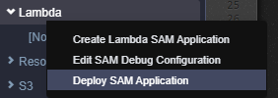

12. create and name your own bucket

13. create cloud formation stack

14. terminal window will show stack updated status.

15. from IDE

16. right click o lambda function

17. select invoke on AWS

18. check s3 for new bucket.

Creating IAM user for collaboration

1. In other tab -Open IAM Identity and Access Management to Add User.

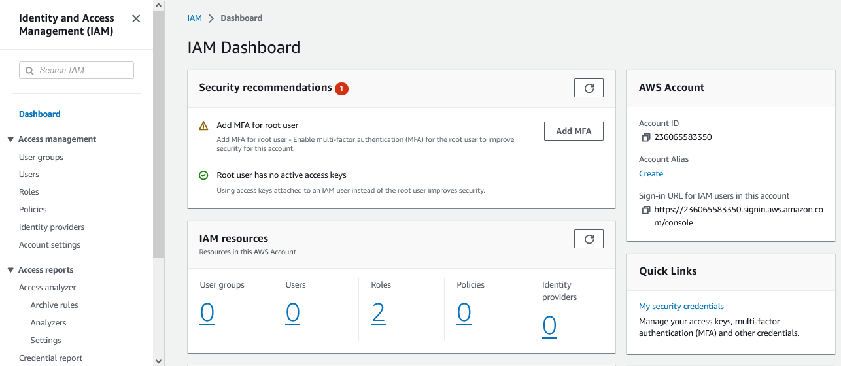

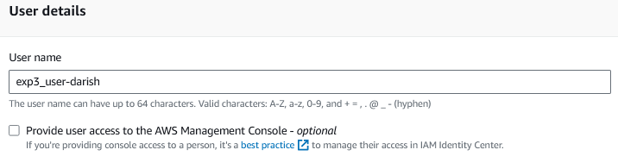

2. Give user console access , Provide user with custom password.

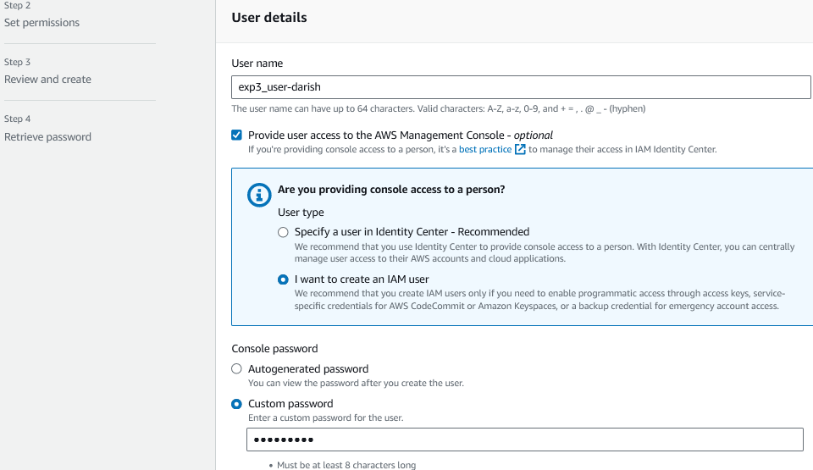

**3.** Create group from IAM

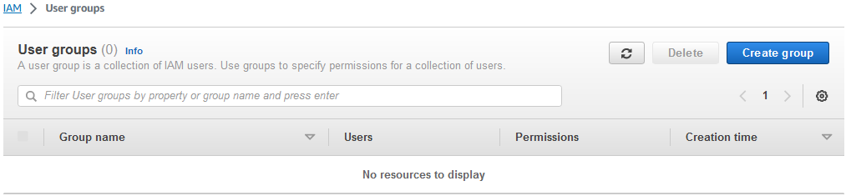

**4.** Provide group name and click on create group.

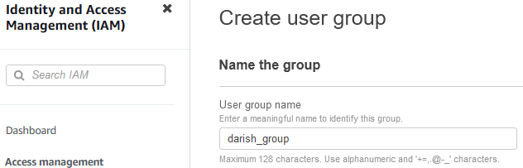

**5. Navigate to user Groups from left pane in IAM.**

6. click on your group name which you have created and nevigate to permission tab

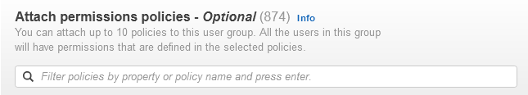

7. Add permission and select Attach Policy after that search for Cloud9 related policy and select **Awscloud9EnviornmentMember** policy and add it.

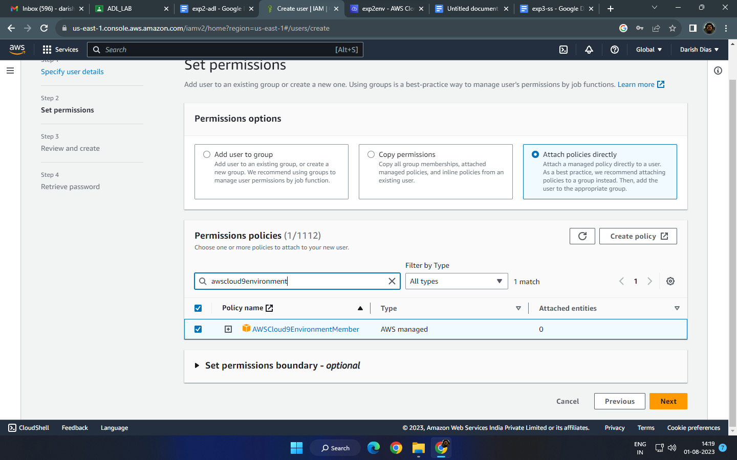

8. Move towards cloud9 IDE Enviornment tab

9. Coud9 IDE has 1. file organiser, 2. coding window and 3. aws integrated CLI with some preinstalled softwares like git, node, python.

10. for command operations: check git, node and python version, iam user details etc. 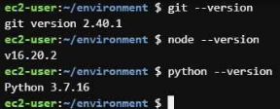

11. Lets setup collaborative enviornment

12. Click on File - choose from template, select html file to collaborate.

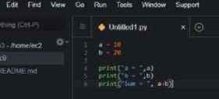

13. Edit html file and save it

14. Share this file to collaborate with other members of the team. Click on Share option on Top Right Pane, write username which you created in IAM , check the accesses given (RW) and send Invite. Click on Done. Click OK for Security warning.

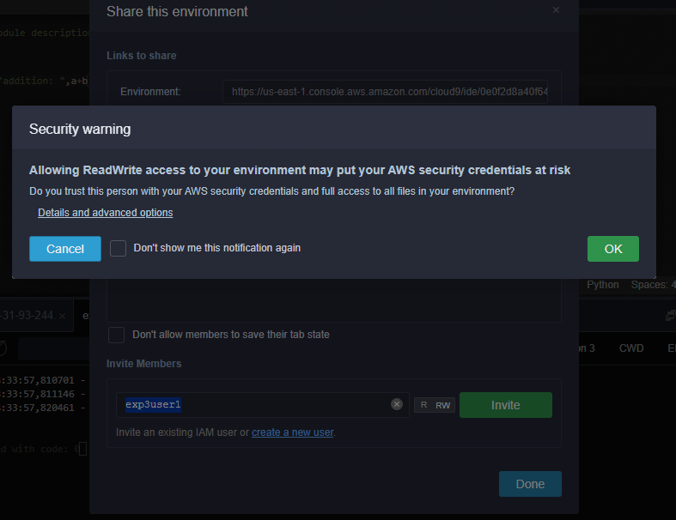

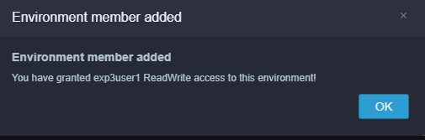

15. Now Open your Browsers Incognito Window and login with IAM user which you configured before.

16. After Successful login with IAM user open Cloud9 service from dashboard services and click on *shared with you enviornment* to collaborate.

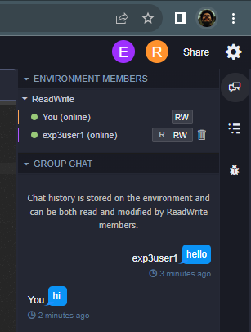 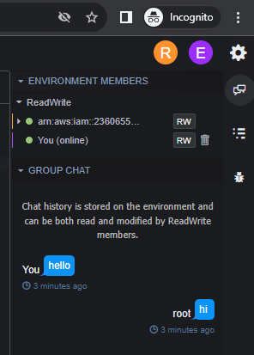

17. Click on Open IDE you will see same interface as your other member have to collaborate in real time, also you all within team can do group chats

18. You can also explore settings where you can update permissions of your teammates as from RW to R only or you can remove user too.

**8. Post-Experiments Exercise**

**A. Extended Theory:** (attach SS)

● Download existing lambda function, make changes and save changes.

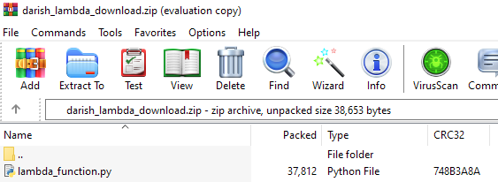

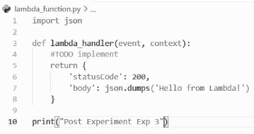

● Change IDE font size

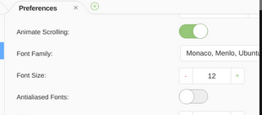 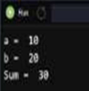

**B. Questions:**(write in hand)

Q.1What is the pricing for AWS Cloud9 free tier?

Q. 2 Match the following (after print wiith black pen)

| Sr No | Item 1 Item 2 |
| --- | --- |
| 1 | command line  amazon chime sdk  tools  android |
| 2 | communication &  WebStorm  collaboration SDK |
| 3 | AWS devops &  power shell  automation |
| 4 | IDE & IDE  AWS Code Pipeline  Toolkits |

**C. Conclusion:**(Write in Hand)

1. Write what was performed in the experiment

2. Mention few applications of what was studied.

3. Write the significance of the studied topic

**D. References:**

a. https://docs.aws.amazon.com/cloud9/latest/user-guide/aws-cloud9-ug.pdf b. https://aws.amazon.com/cloud9/faqs/

c. https://aws.amazon.com/developer/tools/

---------------------------------